**FOSS4G-ASIA 2018 Letter of Intent for Tsukuba, Japan**

We, OSGeo Japan Chapter (OSGeo.JP) are pleased to announce our candidacy to host FOSS4G-ASIA 2018 conference at [International Congress Center EPOCHAL TSUKUBA](http://www.epochal.or.jp/eng/index.html) in Tsukuba, Japan.

# A) Dates

We plan to hold the FOSS4G-ASIA 2018 from October to November. The first candidate is from 31st October to 2nd November, the second is 27th November to 29th November. This is one of the most beautiful and suitable season not only for conference but also for sightseeing, especially for autumn leaves in mountains. In current plan, we will hold a day for hands-on session, and 2 days for oral presentation and poster session.

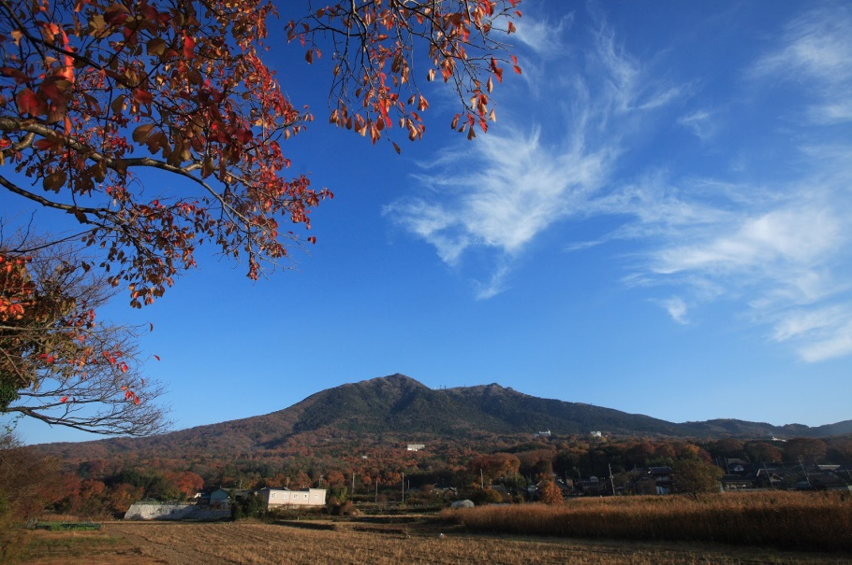

Autumn Leaves in Mount Tsukuba, 45 min from Venue

(Photo by Tsukuba Tourism and Convention Association)

# B) Venue

We will have FOSS4G-ASIA 2018 conference at International Congress Center EPOCHAL TSUKUBA, Japan. Tsukuba City is the center of the academia and D&R, and very diverse city with many foreign researchers. There are many University, National Organization and Research Institute, such as Tsukuba University, The Geospatial Information Authority of Japan (GSI), National Institute of Advanced Industrial Science and Technology (AIST), Japan Aerospace Exploration Agency (JAXA) and National Agriculture and Food Research Organization (NARO). We will expect many participant from these institute.

International Congress Center ‘EPOCHAL TSUKUBA’ is modern and well-equipped place for conference. Many large and important conferences were held in this venue, such as G7 Science and Technology Ministers’ meeting in 2016, the 17th World Lake Conference in 2018 and others. We will book 3rd floor for FOSS4G-ASIA and we can utilize not only Hall and Rooms but also lobby and aisle for demonstration and/or poster session. We can provide comfortable facilities for all participants.

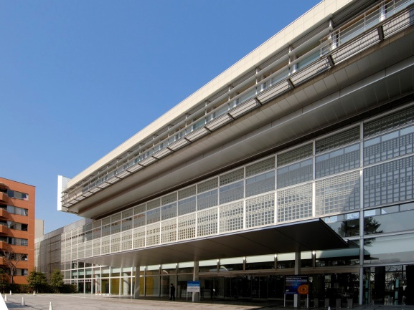 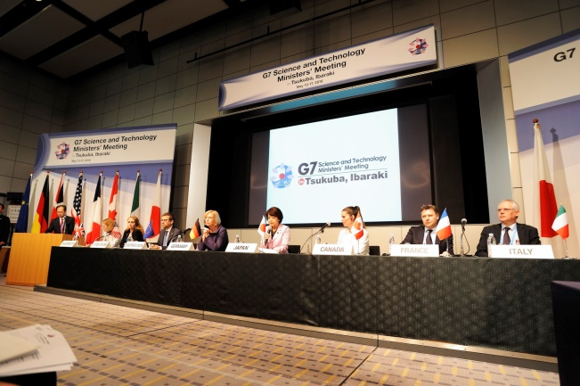

International Congress Center and G7 Science and Technology Ministers’ meeting

(Photo by Tsukuba Tourism and Convention Association)

# c) Availability of hotel rooms near venue and approximate cost for single or shared rooms

There are many conferrable and reasonable hotels near by venue as follows:

* Tsukuba Kenshu Center ( http://www.meikei.or.jp/~center/eindex.htm ): about 30 min. by walk from venue. $33 / day.
* Okura Frontier Hotel Tsukuba Epochal ( http://www.okura-tsukuba.co.jp/eng/ ): just beside of venue. $63 / day.
* Daiwa Roynet Hotel Tsukuba ( http://www.daiwaroynethoteltsukuba.com/en-gb/ ): about 10 min. by walk from venue. $93 / day.

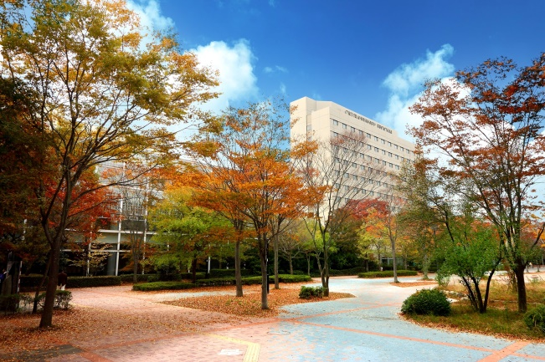 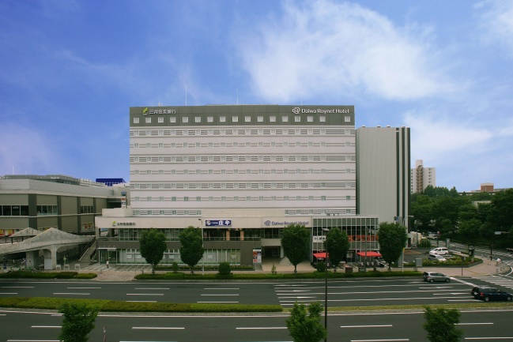

Okura Frontier Hotel Tsukuba Epochal and Daiwa Roynet Hotel Tsukuba

(Photo by Tsukuba Tourism and Convention Association)

# d) Infrastructure available (Meeting rooms available with capacity, Internet Access, Computer rooms for workshops etc.)

We will prepare 3 rooms for workshop (room 302, 303 and 304, total capacity is 120) and one hall and two rooms for Conference (300, 303 and 304, total capacity is 330) and provide Wi-Fi access for individual hall and rooms. We can also use lobby and aisle for poster session and exhibition of sponsors. In addition, we can book other rooms in floor 2 or 4 as needed. <https://www.epochal.or.jp/eng/floor_guide/index.html>

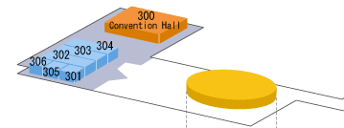

Floor map of the venue

# e) Main organizers and possible list of supporting organizations

FOSS4G-ASIA 2018 will organize by OSGeo.JP, and OpenStreetMap Foundation Japan, Code for Japan, GIS Association of Japan (GISA), Japan Society of Photogrammetry and Remote Sensing (JSPRS) will co-organize conference.

Also, we will ask support for conference to GSI, AIST, JAXA, NARO and other National Research Institute. They are utilized many FOSS4G tools in their works and researches, and we have strong and intimate relationship between these organizations.

# f) Potential sponsors

OSGeo Japan chapter is supported by 17 companies as sponsor and there are a lot of geospatial related companies in Japan. They are interested in business market in Asia and potential sponsors of FOSS4G-ASIA 2018.

In addition, we have already saved enough funds for FOSS4G-ASIA. So, we plan to request additional support to these companies for travel grant/scholarship of conference. Additionally, Tsukuba City and Tsukuba Tourism and Convention Association will support us with a grant for conference.

# g) Transportation and access to venue

The venue (International Congress Center Tsukuba) is located at convenient place for both participants come from abroad using international airport and participants in Japan. It takes less than 10 min. by walk from nearest station (Tsukuba sta.) to the venue. You can access to the Tsukuba station about 55 min. by train from Narita International Airport [NRT]. NRT airport is one of the biggest hub airport in Asia and many LCC are available, from Incheon (Seoul, 2.5hr), Taipei(3.5hr), Manila (Ninoy Aquino, 4.5hr), Hong Kong (5hr), Don Mueang (Bangkok, 6hr), Singapore Changi (7hr) and others.

There is direct express train (Tsukuba EX.) between famous attractive city Akihabara and Tsukuba station, about 45 min. Additionally, many of other transportation ways (express bus from Tokyo sta., express bus from Tokyo International Airport [HND]) are also available.

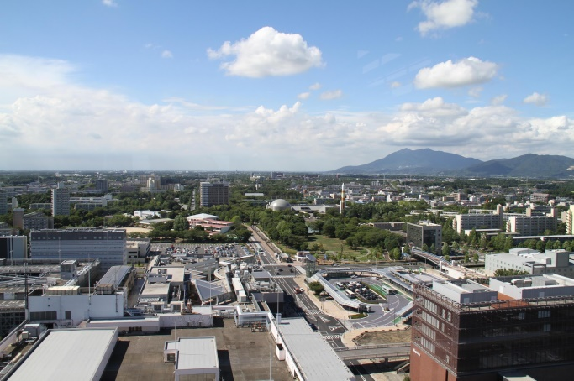

Central Area of Tsukuba

(Photo by Tsukuba Tourism and Convention Association)

# h) Members of LoC

Conference Chair: Toru Mori (Representative, OSGeo.JP)

Local Organizing Committee Chair (including Public Relation): Nobusuke Iwasaki (Vice representative, OSGeo.JP)

Program committee: Hirofumi Hayashi, Yusuke Suzuki, Ko Nagase, Hideki Yachi

Workshop organization: Yoichi Kayama, Taro Matsuzawa, Yoichi Seino, Mitsunori Ueda

Financial Issues: Keiichi Katsube, Kohsuke Asahi

Social-events-organizer: Masaharu Ohashi, Hideo Tarumi, Takashige Nakagawa

Scientific committee: Takayuki Nuimura, Yuichiro Nishimura, Toshikazu Seto, Naoki Ishitsuka

And we will hire assistant for Homepage and Office.

# i) Any other information that will help the Selection committee to arrive at a decision

* OSGeo.JP is one of the most active local chapters in the world. We hold two or three local FOSS4G Conferences every year and invite about 40 guests from foreign countries from 2006. We have enough ability and experience to operate FOSS4G-ASIA.
* We have strong relationship with National research institutes and organizations of Japan. Especially, the Geospatial Information Authority of Japan (GSI) utilize FOSS4G tools for their work and made a keynote speech at FOSS4G conference in Japan every year. Their strong support can be expected.
* The OpenStreetMap Foundation Japan is one of the important co-organizer of FOSS4G ASIA and they organized Global SotM in Japan, 2012 and 2016. We can share experience and knowledge for organizing conference with them.
* We have already saved enough funds for FOSS4G-ASIA, more than $50,000. We will use the funds efficiently and support for travel and conference fee. And we hope this support make a FOSS4G community in ASIA more strongly and passionately.