HOA LU ANCIENT CAPITAL – TAM COC BICH DONG TOUR
Duration: 1 Day / Departure: 27/09/2026
Transportation: 29-seat Thaco coach
Price: VND 980,000/person (applicable to groups of 15 adults or more)

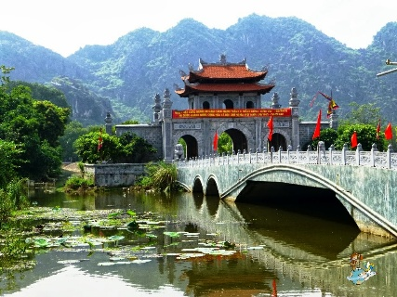
HIGHLIGHTS
Hoa Lu is a semi-mountainous area featuring many beautiful natural landscapes, including the Trang An and Tam Coc - Bich Dong cave complexes, alongside historical relics belonging to the Hoa Lu Ancient Capital complex, which was established and preserved more than 1,000 years ago. Tam Coc - Bich Dong, also famously known as “Ha Long Bay on Land” and “the Second Most Beautiful Grotto in Vietnam”, is one of Vietnam’s key national tourist destinations.
DETAILED ITINERARY
Morning: The coach and tour guide will pick you up at No. 3B, Alley 82, Duy Tan Street, Cau Giay, Hanoi, Vietnamand depart for Ninh Binh. Visit Hoa Lu Ancient Capital, the first capital of Vietnam. You will be impressed by the distinctive architecture of the temples dedicated to King Dinh and King Le, the first and second emperors of ancient Vietnam; the temples were built in the 17th century. Lunch and rest at a local restaurant.
Afternoon: Continue to Tam Coc - Bich Dong. Covering an area of 350.3 hectares, this scenic site is a complex of limestone caves surrounded by peaceful rural landscapes. The area is also home to Bich Dong Pagoda, which features traditional Vietnamese architecture, as well as historical relics associated with the Vu Lam Royal Residence of the Tran Dynasty. Enjoy an afternoon snack, then board the coach for the return journey to Hanoi. Upon arrival in Hanoi, the coach will drop you off at the original meeting point. Farewell and end of the tour!
Note:
The program and itinerary are subject to change without prior notice due to weather conditions and other objective circumstances.
INCLUDED
1. Transportation by coach throughout the itinerary
2. Vietnamese-speaking tour guide throughout the itinerary
3. Entrance tickets to attractions included in the program and shared boat ride at Tam Coc
4. 01 lunch valued at VND 150,000/person
5. Drinking water and a cold towel on the coach: 1 bottle and 1 towel/person/day
6. Travel insurance with maximum coverage of VND 30,000,000/person/incident
NOT INCLUDED
- VAT
- Beverages during meals
- Tips for the tour guide and driver, and personal expenses
CHILD POLICY
1. Children aged 1-4: Free of charge; services are shared with parents
2. Children aged 5-9: Charged at 70% of the adult price and entitled to the same services as adults
3. Children aged 10 and above: Charged at the adult rate

